

Specialty Yogurt

Group 10 | Process Design B

Amy Cheung (H00262730)

Maria Caeli (H00246569)

Harry Nicholl (H00217345)

Murtaza Naqvi (H00247206)

Bethany Mulliner (H00238016)

Table of Contents

Executive Summary 1

Introduction 2

SWOT Analysis 2

Market Analysis 2

Process Description and Flow Sheeting 5

Basic Process Block 5

Process Description 5

Mass Balance 8

Overall P&ID 11

Basic P&ID on the Basis of One Cycle 12

Energy Balance 12

Health and Safety 14

Introduction 14

Reception of the Milk 14

Storage of Milk 15

Pasteurisation of Milk 15

Fermentation 15

Production under Aseptic Condition 15

Cleaning 15

Sustainability 17

Environmental Sustainability 17

Introduction 17

Environmental Impact Summary Table 17

Cradle-to-Grave Diagram 18

Construction 19

Operation 19

Decommission 20

Economic Sustainability 20

Social Sustainability 20

Environment 20

Hazard Identification of Chemicals Within Process 20

Economic Analysis 22

Capital Expenses (CAPEx) 22

Operating Costs (opex) 23

Net Cashflow 24

Net Present Worth 26

Payback Period 27

Profitability Index 28

Sensitivity Analysis 28

Conclusions and Recommendations 30

Appendices 31

Meeting Minutes 38

References 47

Market Analysis 47

Process Description and Flowsheeting 48

Sustainability 49

Health and Safety 49

Economics……………………………………………………………………………………………………………………………………………51

# Executive Summary

Greek Yoghurt is a rapidly growing market from the early 2000’s and it has a global market presence estimated to be worth $77,679 million and by the year 2023 this is expected to be worth $100,000 million. With the largest EU consumer being France, whose combined revenue is expected to total $4,215 million and is predicted to grow annually 0.2%.

This report will provide a comprehensive breakdown into the feasibility of developing a dairy processing plant in the Dusseldorf region of Germany. Dusseldorf was selected for its strong transport links, readily available raw materials and the access this would provide to our targeted markets. These targeted markets being France, Italy, UK, Ireland and of course Germany, the proximity of Dusseldorf to the four former markets and its transport links between them was pivotal in our decision making. Outside of this, the political stability and generous government incentives for a new company were also considered to be attractive qualities, with the only detriment associated being the costs of developing in Germany such as land costs, labour and taxes.

Buff Yoghurt’s unique feature is that it will be produced from buffalo milk instead of the traditional method of cow’s milk. The target demographic will be aiming to take advantage of the recent boom in the health foods department marketed to athletes, gym goers and fans of tasty yoghurt alike. The marketing strategy will centre around 4 key facets; the low lactose content to accommodate those with lactose intolerance, higher protein content than traditional yoghurt will be attractive to athletes, higher calcium which is good for your bones and lower cholesterol which is beneficial for all-round health.

The buffalo milk consumed per annum will be 9,436,000kg of which 8,8880,000kg will be used in the yoghurt production. The annual throughput of Greek yoghurt is expected to be 2.96million kg and 554,000 kg of surplus standardised cream. The 2 waste products generated from yoghurt production is acid whey and contaminated cleaning water. They whey is to be marketed back to the farmers in return for a renegotiation of the price of the milk feed. The wastewater is to be processed on site so that it is safe to re-enter the national water treatment system. These cleaning cycles occur in between each batch of yoghurt as mandated by the EU in the General Food Law Regulation (article 5 to 10).

In an effort to increase revenue in the future, different flavours will be looked at along with alternative uses of the acidic whey such as disposal via bioreactor to generate energy for the plant to use, this would decrease our utilities expenditure greatly. Across the expected 15-year lifespan of the project the potential revenue would total of $197.61 million.

With milk being essentially our only feedstock, it is vital that we take into account each and every possible scenario when discussing its impact on the environment along with the health and safety in the overall plant. This report contains a detailed explanation of all the risks incurred to either the environment or the staff and the chosen methods to asses and combat them.

This report will provide Buff Yoghurt with the insight necessary to plan for the future development of the company and hopefully generate an expanding market share, which will reap financial reward for all parties involved.

1

# Introduction

This report provides detailed insight into setting up and running a yogurt manufacturing plant. It covers all the prerequisites for yogurt industry by examining the global yogurt market trend, customer behavioural, site location, project cost and economics, returns on investments, profits, process (PFD, material and energy balances) and SWOT diagram. Furthermore, the report will also present health and safety analysis.

***Yogurt***

Yogurt is made by fermenting milk with bacteria. The bacteria used to make yogurt is *Lactobacillus bulgaricus* and *Streptococcus thermophillus,* these bacteria are known as yogurt culture. Consuming yogurt has long known to be beneficial to digestive and wellness. It offers many essential nutrients such as protein and calcium, in addition to nutrients content, yogurt also contains probiotics and is recommended as a healthy food.

## SWOT analysis

|  |  |
| --- | --- |
| **Strengths** | **Weaknesses** |
| - Offer more health benefits  - Lower lactose content in buffalo milk  compared to cow’s milk-based product  - Predicted to grow at a CAGR of 4.6%  - Yogurt consumption in Europe relatively  more mature compared to other regions  - Strategic location and adequate  transport links | - Lack of brand awareness  - Cost competitiveness  - By-product (whey acid) may  be harmful to the environment if  not treated correctly |
| **Opportunities** | **Threats** |
| - Growth in demand amongst health-  conscious public for nutritious food  - Potential for new product variation  such as yogurt drink | - Availability of raw materials  - Sales resistance due to consumer  unfamiliarity towards the product  - Established competitors |

*Table 1: SWOT analysis*

## Market Analysis

**Global Trends**

An increasing trend amongst costumers towards a healthier lifestyle and wiser purchasing habits has been noticed for the past few years. (Statista, 2018) According to the research conducted by *Food Insight,* out of ten consumers, seven are willing to give up the product their familiar with for the new one that is more natural, i.e did not contain any artificial additives. (Foodinsight.org, 2018) This finding supported the analysis of consumer behaviour made by a well-established magazine, *Forbes,* who stated that modern societies are no longer brand loyal. (Forbes.com, 2018)

2

Furthermore, out of the seven consumers who would, four are willing to pay an additional of 50% and one would pay an additional of 100% for the new product. Based on these facts, we believed that our product would thrive in the global market.

**Yogurt Trends**

Due to the increased awareness and health perception associated with yogurt, the global yogurt market is continuing to develop at a moderate rate. Researched done by *Allied Market Research* projected that the global yogurt market is growing at a CAGR of 4.6% from 2017-2023. (Allied Market Research, 2017) Furthermore, they forecasted that the market is to reach more than $100,000 million by 2023. This number increases from $77,679 million in 2016. (Research, 2018) Asia-Pacific and Europe play an important part by contributing to more than 70% of the total global yogurt market in 2016 due to large consumption and popularity of yogurt products there.

Finally, low-lactose content yogurt is becoming more popular between people who have lactose intolerant. A report published by *Genetic Home Reference*, claims that about 65% of the world’s population has an inability to digest lactose. (Reference, 2019) An alternative for low lactose content products shows a strong performance, especially in Western Europe, by registering a CAGR of 12% throughout 2013-2017 and are expected to continue to grow. (Agr.gc.ca, 2018)

**Target Market and Location**

To maximise both production and sales of Buff Yogurt, the plant should be placed in the most strategic location. The location was determined after doing extensive research that covers the market of potential customers and the overall feasibility and sustainability.

***Potential Market***

The rising awareness regarding the benefits of yogurt as a source of calcium and protein, boost the immune system and contains good probiotics (bacteria) is one crucial aspect that drive the demand of yogurt market and make it prominent in the recent years. This shift in dietary behavioural towards yogurt consumption - particularly in Europe, this has made Europe dominates the global yogurt market. (Bizjournals.com, 2017)

The claim was further supported by *Allied Market* who provides data on annual per capita yogurt consumption in 24 countries, see *Figure 1,* (Appendix, Marketing). The graph clearly indicates that European people have higher yogurt consumption per person compared to other regions. (Allied Market Research, 2017)

A report made by *Dairy UK* states that the dairy sector also plays a major role throughout the UK. This was supported by research showing a large proportion of adults (78%) consume yogurt and half of them who does doing it twice or more in a week. (Dairy UK, 2018) In addition, Asia-pacific was found to be a leading region, contributing the highest CAGR of 5.4% in the global yogurt market followed by North America. (Allied Market Research, 2017) However, considering the cost, availability of raw materials and political environment and regulation (in North America), makes the project unfeasible and unsustainable.

3

***Decision Matrix***

In order to assess the most feasible and sustainable region, all potential market locations are compared and summarised in the decision matrix table shown below:

|  |  |  |  |  |  |
| --- | --- | --- | --- | --- | --- |
|  | **Weight (%)** | **Locations** | | | |
| **Germany** | **China** | **UK** | **US** |
| **Cost (Land, Employee, Taxes** | **20** | 50 | 70 | 40 | 60 |
| **Access to Major Markets** | **20** | 80 | 40 | 70 | 50 |
| **Transportation** | **20** | 70 | 40 | 70 | 70 |
| **Availability of Raw Materials** | **20** | 70 | 90 | 70 | 40 |
| **Political Environment and Regulations** | **20** | 60 | 40 | 60 | 50 |
| **Total** | **100** | **66** | **56** | **62** | **54** |

*Table 2: Decision Matrix*

**Site**

Buff Yogurt plant will be located in Düsseldorf, Germany with a total site area of 1.0 km2. The land will accommodate offices, warehouse, storage and other sectors; production and packaging and wastewater treatment site.

***Geography and Demographics***

Düsseldorf lies in the centre of the Rhine-Ruhr metropolitan region and southwest from the Ruhr urban area. (En.wikipedia.org, 2019) As Germany’s 7th largest city there has been an increase in population over the years with a total of just over 630,000 people (2017). According to the *World Population Review,* Düsseldorf is one of the most influential city in Germany, and its fair and trade have become well-known internationally. (Worldpopulationreview.com, 2019) Its location proximity to potential market (France, Italy, UK and Ireland) will reduce exporting cost. Furthermore, more than 1,000 trains stop at Düsseldorf daily, making it the major hub in the railway network. Providing easy access for transporting the end-product to local areas.

**Market Distribution**

30,000L of fresh buffalo milk will be processed each day, where a third of it yielding in yogurt, as the main product and the rest of it being a by-product – cream and whey. The yogurt will be distributed to the local area by a percentage of 25% and the rest of it will be exported to other countries such as France, Italy, United Kingdom and Ireland. The by-product will be marketed back to the farmers.

**Objectives and Marketing Strategy**

Buff Yogurt’s prime objective is to establish an innovative and natural yogurt product which offers more health benefits to consumer. Buff Yogurt is made from 100% buffalo milk which contains higher protein (10-11%), higher content of calcium and less cholesterol compared to cow’s milk.

4

# Process Description and Flow sheeting

## Basic process block

*Figure 1: block diagram for the yoghurt production process*

This is our basic block diagram for the yoghurt production, it includes all the important sections of our design. The orange blocks represent heat exchangers both heating and cooling, the yellow blocks are the different operations performed on the milk, the white blocks are material input and output whilst the blue blocks are the finishing processes to ready the yoghurt for transportation. This block diagram will be used going forward for the benefit of simplicity when approaching the remainder of this report.

## Process description

The first yoghurt appeared 9000 to 8000 years BC in Egypt and Mesopotamia, from there spreading throughout the African and Asian continents. It was particularly useful method of preserving foodstuffs that otherwise would have been spoiled such as milk. Originally yoghurt was the result of a spontaneous and accidental fermentation of lactose which lead to the acidification and coagulation of milk. It is believed the earliest yoghurts were likely fermented spontaneously by wild bacteria (Canada, 2019) in goat skin bags, since then the process has been infinitely more refined and perfected in order to produce consistently high quality yoghurt with every batch. The modern day process will be outlined below;

Modern yoghurt as we know it, remains a fermented milk product containing the characteristic bacterial cultures *Lactobacillus bulgaricus* and *Streptococcus thermophilus*. This specific yoghurt will be Greek style produced using Buffalo milk instead of regular cow or sheep milk which are the 2 most common methods for Greek yoghurt production. (Yogurt, 2019). The raw milk feed is to be supplied from the Buffalo farmers with a daily consumption of 28,000L per day. To accommodate this, the plan is to receive 120,000L of raw milk every 4th day. This time frame is ideal, it is short enough to ensure the milk remains fresh and it ensures there will always be enough milk to run the plant at the desired specifications. As a contingency we plan to have a 6% excess of raw materials available for each process, this will be necessary as any contamination of the milk would require the whole batch to be purged.

5

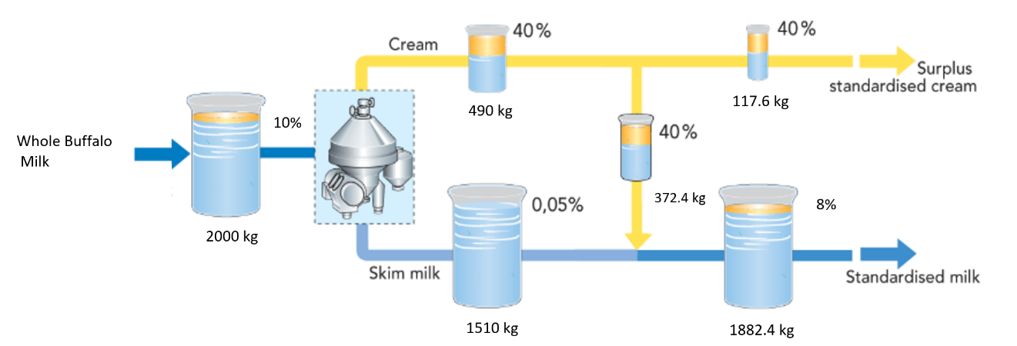Before any processing of the milk can occur, it is standardized, this procedure allows a fraction of the fat content to be skimmed off to produce 40% standardized cream which is a more valuable product. The initial milk fat content is brought in at 10% from the farmers, of that all fat will be removed from the milk by means of a centrifuge leaving ≤0.015% fat by mass. This skimmed milk is then reincorporated with the 40% standardized cream, with 372.4kg of cream being added to the 1510kg of skimmed milk to produce 8% standardized buffalo milk ready to be used in the yoghurt making process. With respect to one cycle, the standardization of 2000kg 10% whole milk will yield 1882.4kg of 8% milk, leaving 117.6kg of 40% cream ready to be sold on as surplus. The process can be more accurately demonstrated with the use of the graphic below, figure 2 gives a detailed summary of the standardization process.

*Figure 2: Standardisation process schematic*

(Dairy Processing Handbook, 2019)

The next step in the process is pasteurisation of the raw milk, this is done in order to kill any living bacteria within the milk. This will make it safe to drink and therefore safe to process into yoghurt. The milk is pasteurised at 85˚C for 30 minutes or 95 ˚C for 10 minutes, in our case we chose the latter option as high heat treatment is used to denature the microorganisms which cause spoilage of the milk (Sfakianakis and Tzia, 2014). This reduction of microorganisms present in the milk is to provide the sterile conditions required for the 2 starter cultures mentioned above. Yoghurt is pasteurised before the starter cultures are added because the pasteurisation process would denature and therefore inactivate the desired bacteria present in the milk which ultimately would result in milk fermentation. The secondary benefit of these bacteria remaining active within the milk mixture after fermentation to acts as probiotics. The majority of the health benefits can be seen in the digestive system, in particular cultures *Lactobacillus bulgaricus* and *Streptococcus thermophilus* are very useful to those afflicted with lactose intolerance and IBS. (Donkor et al., 2006)

The third step in the process is the homogenisation of the pasteurised milk, the mixture is blended at a pressure of 2000-2500 psi in order to achieve a thorough mixing of the assimilated milk and cream. This will reduces the size of fat globules which is essential for the final flavour and consistency of the product. The blended mixture is then cooled to 44˚C (Radke-Mitchell, 2019) which is the average of the optimum temperature for the two strains of bacteria. This cooled milk can now be transferred to the fermentation tank and at this point the two starter cultures can be added to the milk. The increased kinetic energy from the 44˚C fermentation temperature means that the fermentation time is only 6 hours.

The milk fermentation process is a very simple one involving two thermophilic bacteria, *Lactobacillus bulgaricus* and *Streptococcus thermophiles.* These two species operate in harmony, forming a mutually beneficial protocooperation. This relationship provides nutrients and conditions necessary for each to achieve optimal conversion of lactose to lactic acid (M. Abd Elhamid and M. Elbayoumi, 2017). This acidification of the milk is essential in order to produce yoghurt, the different metabolites of this fermentation being lactic acid, exopolysaccharides and aroma compounds which in turn modifies the texture, taste and nutritional content of the product. Below is figure 3 which provides a very simple schematic of the reactions that occur in order to produce the lactic acid.

6

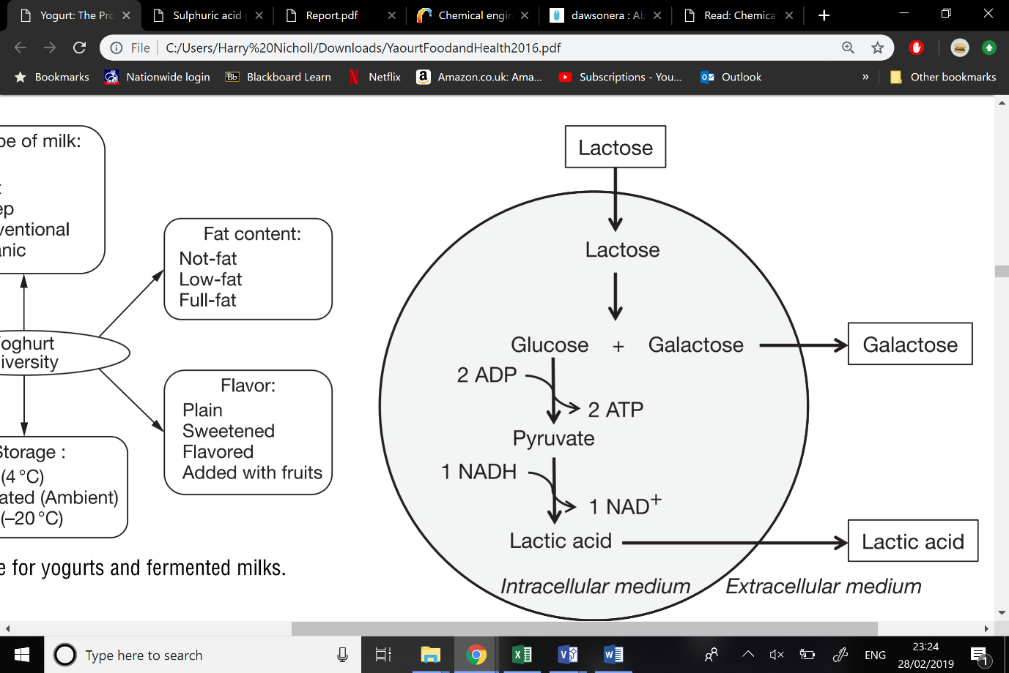

[Grab your reader’s attention with a great quote from the document or use this space to emphasize a key point. To place this text box anywhere on the page, just drag it.]

(Corrieu, G. and Beal, C. (2016))

(Corrieu, G. and Beal, C. (2016))

*Figure 3: Lactose fermentation process*

To end the fermentation process the mixture is cooled to 7˚C, at this temperature the bacteria is no longer able to undergo metabolic activity below 10°C. We are aiming for a final pH of 4.2 (Corrieu, G. and Beal, C. (2016)) to give the best yoghurt texture and flavour, this is best confirmed with manual sampling to avoid cross contamination of instruments and the glass pH probes typically installed on fermentation tanks could be smashed by the mixing process. Any glass entering the mixture would result in spoilage of the entire batch. Greek yoghurt is a strained yoghurt, this straining is completed by a centrifuge. The centrifuging will give two products, the desired Greek yoghurt and the undesired bi product acidic whey. Once this plain yoghurt is separated from the whey it is our final product. It can now be packaged to our specification using a standard packaging setup which moulds the plastic cups, wraps around a paper label containing the nutritional breakdown and the ingredients along with the marketing. Finally, the tub is sealed with an aluminium foil to keep the product fresh and contaminant free. The air in this section of the plant must be very sterile so that the sterile yoghurt cannot be contaminated by airborne pathogens. (Dairy Processing Handbook, 2019)

The finished product must remain chilled in order to maintain the benefits of having probiotic bacteria in the finished product as they will degrade upon exposure to room temperature (Scharl et al., 2010). At the end of each cycle each part of the equipment in contact with the mixture will need to be thoroughly cleaned, the most common industrial cleaner for the dairy industry is NaOH which fulfils both the legal and trade requirements of yoghurt production. The full details of the cleaning cycle will be elaborated on further in the health and safety section.

7

## Mass Balance

As you can see the yoghurt making process is very simple and only requires bacteria and the milk to undergo fermentation. From research it suggests a ratio of 1 part yoghurt to 2 parts whey for the final distribution of the fermentation products. An assumption on the amount of downtime was made for 28 days, this is to accommodate essential inspections, maintenance and any possible repairs. The plant will therefore have an up time of 92.3% producing 2.96 million kg of yoghurt per year with 5.92 million kg of whey coming from a total feed of 9.436 million kg of raw milk per year. The mass balance below is representative of the yoghurt produced across the 5 operating lines installed. Across the 5 reactors, 4718 cycles occur per year with 14 happening every day. Per day this equates to 8,785 kg of yoghurt being produced which is well within the regular threshold of 4000 kg per day to be regarded as a feasible operation (Reklaitis and Schneider, 1983)

The overall mass inputs and outputs can be calculated as follows;

Total Mass of input (kg/year) = (Cycles/year × uptime/year) × milk consumed/cycle

= (14 × 337) × 2000

= 9,436,000 kg/year

Total Mass of outputs (kg/year) = Yoghurt produced + Cream produced + Acid Whey produced

= 2,960,000 + 555,000 + 5,921,000

= 9, 436,000 kg/year

8

|  |  |  |  |  |  |  |  |  |  |  |
| --- | --- | --- | --- | --- | --- | --- | --- | --- | --- | --- |
| ***Reactor 1*** | ***S101*** | ***S102*** | ***S103*** | ***S104*** | ***S105*** | ***S106*** | ***S107*** | ***S108*** | ***S109*** | ***S110*** |
| Milk | 1776232.6 | 1776232.6 | 1776232.6 | 1776232.6 | 1776232.6 | 0 | 0 | 0 | 0 | 0 |
| 2 starter cultures | 0 | 0 | 0 | 0 | 1 | 1 | 1 | 1 | 1 | 1 |
| Whey | 0 | 0 | 0 | 0 | 0 | 1184155.1 | 1184155.1 | 1184155.1 | 0 | 0 |
| Yoghurt | 0 | 0 | 0 | 0 | 0 | 592077.5 | 592077.5 | 592077.5 | 592077.5 | 592077.5 |
| ***Reactor 2*** | ***S201*** | ***S202*** | ***S203*** | ***S204*** | ***S205*** | ***S206*** | ***S207*** | ***S208*** | ***S209*** | ***S210*** |
| Milk | 1776232.6 | 1776232.6 | 1776232.6 | 1776232.6 | 1776232.6 | 0 | 0 | 0 | 0 | 0 |
| 2 starter cultures | 0 | 0 | 0 | 0 | 1 | 1 | 1 | 1 | 1 | 1 |
| Whey | 0 | 0 | 0 | 0 | 0 | 1184155.1 | 1184155.1 | 1184155.1 | 0 | 0 |
| Yoghurt | 0 | 0 | 0 | 0 | 0 | 592077.5 | 592077.5 | 592077.5 | 592077.5 | 592077.5 |
| ***Reactor 3*** | ***S301*** | ***S302*** | ***S303*** | ***S304*** | ***S305*** | ***S306*** | ***S307*** | ***S308*** | ***S309*** | ***S310*** |
| Milk | 1776232.6 | 1776232.6 | 1776232.6 | 1776232.6 | 1776232.6 | 0 | 0 | 0 | 0 | 0 |
| 2 starter cultures | 0 | 0 | 0 | 0 | 1 | 1 | 1 | 1 | 1 | 1 |
| Whey | 0 | 0 | 0 | 0 | 0 | 1184155.1 | 1184155.1 | 1184155.1 | 0 | 0 |
| Yoghurt | 0 | 0 | 0 | 0 | 0 | 592077.5 | 592077.5 | 592077.5 | 592077.5 | 592077.5 |
| ***Reactor 4*** | ***S401*** | ***S402*** | ***S403*** | ***S404*** | ***S405*** | ***S406*** | ***S407*** | ***S408*** | ***S409*** | ***S410*** |
| Milk | 1776232.6 | 1776232.6 | 1776232.6 | 1776232.6 | 1776232.6 | 0 | 0 | 0 | 0 | 0 |
| 2 starter cultures | 0 | 0 | 0 | 0 | 1 | 1 | 1 | 1 | 1 | 1 |
| Whey | 0 | 0 | 0 | 0 | 0 | 1184155.1 | 1184155.1 | 1184155.1 | 0 | 0 |
| Yoghurt | 0 | 0 | 0 | 0 | 0 | 592077.5 | 592077.5 | 592077.5 | 592077.5 | 592077.5 |
| ***Reactor 5*** | ***S501*** | ***S502*** | ***S503*** | ***S504*** | ***S505*** | ***S506*** | ***S507*** | ***S508*** | ***S509*** | ***S510*** |
| Milk | 1776232.6 | 1776232.6 | 1776232.6 | 1776232.6 | 1776232.6 | 0 | 0 | 0 | 0 | 0 |
| 2 starter cultures | 0 | 0 | 0 | 0 | 1 | 1 | 1 | 1 | 1 | 1 |
| Whey | 0 | 0 | 0 | 0 | 0 | 1184155.1 | 1184155.1 | 1184155.1 | 0 | 0 |
| Yoghurt | 0 | 0 | 0 | 0 | 0 | 592077.5 | 592077.5 | 592077.5 | 592077.5 | 592077.5 |

*Table 3: Mass balance for one year of operation*

10

## Overall P&ID

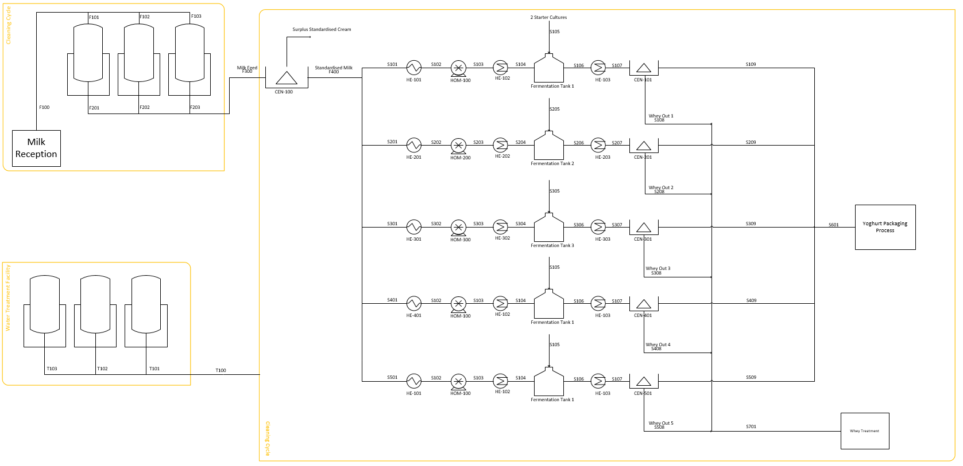

*Figure 4: Overall P&ID*

11

## Basic P&id on the basis of one cycle

*Figure 5: Basic P&ID for one cycle*

Key equipment and function –

HE-101 Heat exchanger that pasteurises the raw milk feed

HE-102 Cool the milk feed to 42C

Fermentation tank 1 reaction vessel for the milk fermentation to occur

HE-103 Further cools the milk to 7C to end the fermentation process

CEN-101 Centrifuge to remove the whey from the yoghurt

This is a very simple version of the P&ID used to model the core processes the Greek yoghurt production. Figure 5 omits the milk reception, standardisation and packaging processes. A comprehensive P&ID for the entire plant can be found above, it includes the aforementioned missing processes along with cleaning cycle loops along with the water and whey treatment facilities.

## Energy Balance

An energy balance would be of limited use for the yoghurt production process, a more useful basis would be the figures on how much energy is consumed per cycle. The most important components of the process is pasteurisation, homogenisation and the two cooling operations. Below is the energy consumed

|  |  |
| --- | --- |
| ***Process*** | ***Energy consumed/cycle (kW)*** |
| Pasteurisation | 8.41 |
| Homogenisation | 13.62 |
| Cool 1 (75°C - 44°C) | 2.08 |
| Cool 2 (44°C - 7°C) | 2.22 |

*Table 4: Energy consumed during the process*

The total energy expenditure across the process for the main components is 26.33kW this rises to a total of 45kW with the rest of the components considered. The homogenizer is what consumes the most energy, this makes sense as it must reach 2500psi to ensure thorough mixing and fat globule shrinking. The packaging process is expected to consume 5kW of energy per cycle this is a highly automated process which means that very little operator input is required. The energy requirement and its associated cost for utilities could be drastically reduced in the future with the use of an anaerobic digester which can break down the acidic whey to produce methane gas which can be used to produce energy for the plant. To further offset utility expenditure there is a possibility of selling excess energy produced from the digester back to the national grid. The main difficulty faced with this energy balance is the lack of data available for the energetics of the reaction occurring within the fermentation vessel. From external reading the energy requirement for yoghurt production is very similar to that for the production of milk. The average energy requirement for the production of 1,000kg of yoghurt is 402kW (Karousou and Stefanou, n.d.), which is in line with our figures which adds up to 287kW. This is only 7% above the average (Ghafoor and Munir, 2014). This can be attributed to inefficiencies of a small start-up plant but there is potential for this to be brought down to be in line with the dairy industry standards. An energy balance is a fundamental necessity of any new business venture and the benefits associated allow for optimisation of the process further down the line.

12

13

# Health and Safety

## Introduction

The yogurt production plant will follow all the rules and regulations set by the European Commission. The Production plant is to be located in an industrial area in Düsseldorf, Germany.

The primary function of the plant is to produce yogurt, the major risks associated with this process are:

* Pathogens in the raw milk such as E. coli, these
* The fermentation of bacteria must be strictly controlled as other unwanted and potentially dangerous bacteria can form alongside the
* Risk of contamination from fungi
* Leaks
* Waste water

In order to minimise risks the HACCP system will be implemented into the production. Hazard Analysis Critical Control Point, (HACCP) is an internationally recognized, food safety system that aims to prevent, eliminate and reduce hazards.

Total of 10 critical control points (CCPs) were identified:

1. Reception of the raw milk
2. Storage of the raw milk
3. Milk pasteurization
4. Fermentation
5. Cooling
6. Addition of ingredients
7. Filling
8. Storage of the finished product
9. Dispatching of the product
10. Sanitization of the equipment

(Sueli Cusato, 2013)

## Reception of the milk

It will be ensured that farms are EU regulation compliant, and follow the following points when performing animal health checks:

* Somatic cell count, this is an indicator of mastitis, this is EU regulation to ensure good quality milk and is a recognised as an official control by the European Commission, this information must be made available to authorities if required.
* Scoring for lameness, this is conducted by the farmer by noting the behaviour of the buffalo and it indicates the overall degree of affection of the buffalo.
* Body Condition, this is also an indicator which is used widely across the EU, this test is completed by measuring the weight and size of the buffalo.

14

## Storage of milk

To allow for the storage is was ensured that the tank room was kept clean and away from any source of contamination, the surrounding area must be designed to protect the milk from vermin and any other obvious causes of contamination. The access to the milk tank will be created to allow easy access from the tanker to the milk storage tank, access will ensure very minimal contamination of the raw milk is allowed.

Since this is a food storage area the area must be controlled, the placement of storage tank must be away from any direct pathways, the storage area should not be in close proximity of any handling areas, toilets or feed stores. Access to the storage must be minimised only authorised personal should be allowed.

The floor is another aspect that should be considered, the floor should be impervious, and a free draining system should be implemented, for example the floor should be at a slope leading to a trapped drain to allow any spillages to be easily be cleaned and reduce the chance of a slip-on milk causing injury. No external drainage must enter the milk storage area, all surface should be in good condition, any surfaces that are prone to soiling should be smooth and impervious to allow easy cleaning. Doors should be well fitted, they can be both hinged or sliding it is recommended that they are self-closing, any joints should be sealed and also cladding sheet should be used. (Food Standards Agency Scotland (FSAS), 2006)

## Pasteurisation of milk

Along with correct cooling, the heat treatment is one of the most important processes in the treatment of milk. If carried out correctly, these processes will give milk a longer shelf life.  
Temperature and pasteurization time are very important factors which must be specified precisely in relation to the quality of the milk and its shelf-life requirements. The pasteurization temperature for homogenized, HTST pasteurized milk is usually 72 – 75 °C for 15 – 20 seconds.

## Fermentation

### PRODUCTION UNDER ASEPTIC CONDITION

Since the yogurt production contains bacteria, the process must be aseptic because otherwise the yogurt can be infected with yeast and mould. These micro-organisms would cause the product to be contaminated and harmful to ingest. These micro-organisms can survive and multiply in acid environments which can cause and off-taste and cause whey separation.

In order to prevent this some precautionary methods can be taken; the primary method is thorough cleaning and sterilization of all surfaces in contact with milk and other ingredients being added to the process. Other aseptic measures that can be taken are pressurised tanks which pump sterile air into the tank, also aseptic metering devices for fruit and aseptic filling machines can be used.

## Cleaning

Hygienic conditions must be maintained in all food industries, not only in the equipment coming in direct contact with the product, but also in the premises where production takes place. There are four different types of cleaning methods:

* Physical cleanliness – removal of all visible dirt from the surface
* Chemical cleanliness – removal not only of all visible dirt but also of microscopic residues that can be detected by taste or smell but are not visible to the naked eye

15

* Bacteriological cleanliness – attained by disinfection
* Sterile cleanliness – destruction of all microorganisms

16

# Sustainability

Environmental Sustainability

### Introduction

During all implementation phases, product phases and decommissioning phases, our company shall adhere to all relevant EU and German legislation with regards to construction and food safety, most notably Regulation (EC) No 853/2004 of the European Parliament and of the Council “Laying down specific hygiene rules for on the hygiene of foodstuffs”. (The European Parliament and the Council of the European Union, 2004)

### Environmental Impact Summary Table

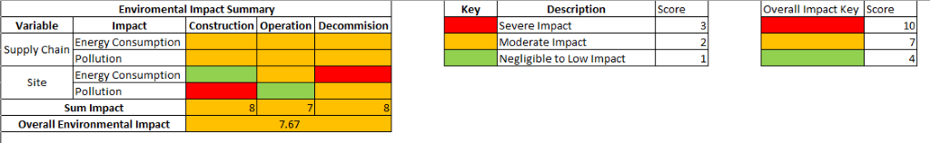

*Table 5: Environmental impact summary*

The following cradle-to-grave diagram details the impacts expected to be caused through the various stages of the life of the company.

17

### Cradle-to-Grave Diagram

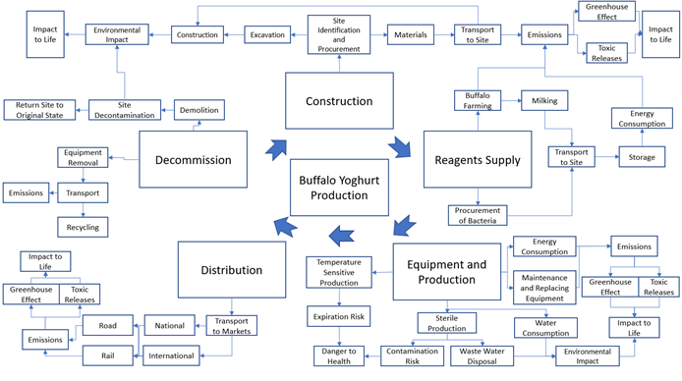

*Figure 6: Cradle to grave diagram*

18

### Construction

To keep damage to the local wildlife and fauna to a minimum, firstly a site should be selected where the impact of the following potential concerns will be minimal.

During the construction of the plant, one of the main concerns is the environmental impact caused by vehicles travelling to and from the site, as well as those operating on site. A large volume of traffic on the roads near to the site and on the site itself will be unavoidable during this phase, causing potentially a large amount of CO2, NOx and particulate matters to be released as vehicle emissions. These vehicles will also generate a large amount of sound pollution and may cause disruption to the local infrastructure, causing a nuisance to the local community. Vehicles on site may also turn up a large amount of dust into the air.

In order to minimise these concerns, Buff Yogurt would look to reduce the number of vehicles on site and vehicles making journeys as much as is realistically possible. We would also encourage contractors to ensure that their vehicles are in proper working order and have catalytic converters or similar filters in good working condition to further reduce emissions. Construction and travel should take place during the day in order to comply with noise regulations and to reduce nuisance caused to the local community.

During excavation, large amounts of dust may again be created and may become airborne, potentially drifting a large distance and causing potential damage to the local biome. To attempt to negate this to an extent, movement of large vehicles and excavation should only be kept to a necessary amount. On areas of the site with heavy vehicle traffic, dust-binders will be used to combat airborne dust particles. (Wibax, n.d.)

### Operation

During operation, a number of trucks will be needed to transport buffalo milk to the plant, and also to transport the finished yoghurt to market. In some cases, this transportation may also include rail. The concerns regarding this are identical to those previously discussed regarding vehicle transportation in the Construction section.

During production, the primary operational concern is the sterile conditions and set temperature conditions which must be met at various stages of the process. Firstly, the incoming milk to be used in production must be tested to ensure it does not exceed EU limits for cell count or for antibiotic residue. Next, during transport and storage it is paramount that the milk is stored at not more than 6˚C. All tanks and equipment involved in the storage of raw milk must be cleaned and disinfected thoroughly between each use, or once a day, whichever is first. The plant itself must be constructed to eliminate the possibility of contamination as much as possible by ensuring all surfaces, equipment, and factory personnel are sufficiently disinfected and as clean as possible. Since bacteria must be introduced to the milk to produce the yoghurt, it is paramount that the bacterial cultures contain no microorganisms other than the bacteria Streptococcus Thermophilus and Lactobacillus Bulgaricus. Staff should be trained in the importance of the high hygiene requirement of the plant, as any small contamination or failure to abide by regulations will result in the product being unsafe to sell and possibly dangerous to health. (The European Parliament and the Council of the European Union, 2004)

Care must be taken during the disinfection process and the cleaning process due to the use of caustic soda solutions, which can be corrosive and must be handled with care. All staff will be made aware of the risks involved with the use of caustic soda and trained appropriately to best mitigate these risks.

During operation, an acidic whey is produced. The acidic whey has no useful food applications due to its toxicity, and hence must be either be sold to external companies for further uses or disposal, or, as a potential future investment, it can be disposed of safely in a bioreactor to produce methane to be used to produce electricity to offset utilities costs. (Erickson, 2017) Care must be taken to ensure that the whey is thoroughly separated from the yoghurt product to avoid potential cross-contamination. The methane produced by the bioreactor is extremely flammable and a greenhouse gas, hence care must be taken to ensure that the methane is collected in a closed system to avoid any possible releases.

19

The waste water produced during production and during cleaning is hazardous due to both the organic matter content, which can potentially deprive water of oxygen, and due to the caustic soda used as the cleaning agent, and hence the waste water must not be flushed into normal drainage systems and must be first processed in a wastewater treatment tank before it can be disposed of safely.

### Decommission

The concerns raised in the Construction section are mostly identical to those during the decommission of the plant. However, it is expected that the number of vehicles required to clear the site would be less than those required during the construction, hence decreasing pollution from emissions. Care must be taken to ensure that all material is cleared from the site in a manner that decreases any permanent impact to the environment and that the site is rejuvenated to a suitable level.

### Economic Sustainability

In Germany, there are several economic advantages that will help Buff Yogurt reduce costs associated with taxes, funding, employee wages and employee training. This will help to raise the profitability of the company and allow us to achieve a return quicker.

In order to further increase the company’s profitability, all useful waste products will be either sold or utilised. Acid whey will either be sold on for further uses or will be given back to farmers for use as fertiliser and feed in return for a decreased price of milk. In the future, to offset costs of utilities, we intend to produce some electricity on site using the fermentation of acidic whey in a bioreactor to produce methane in the future we intend to expand our production capabilities to include producing these further products in-house to further increase profitability. We also intend to fit solar panels to the roof of the facility to further offset costs.

### Social Sustainability

At Buff Yogurt, our workers will be highly trained in the operations of the plant and in food hygiene to ensure both worker safety and the safety of our products.

Buff Yogurt will comply with all EU regulations regarding employee safety and employment opportunities.

## Environment

### Hazard Identification of chemicals within process

In the event of a leak or a spillage, the possible chemicals that would be exposed to the surrounding areas would be:

* Milk
* Acid Whey
* Waste water (mixed with organics)

#### Milk impact on surrounding area

Milk contains pathogens such as Campylobacter spp., enterohaemorrhagic E. coli (EHEC), Salmonella spp. and Listeria monocytogenes. If is milk introduced into water ways it can cause major issues as it can deprive water of oxygen which can cause harm to wild life and the surrounding natural environment and also depending on the body of water can be introduced into the water supply which can cause harm to humans. Therefore, to reduce the risk of mil spillages and leaks the following precautions will be taken.

20

To prevent spillages by overfilling it will be ensured that tank sizes will be larger than required and also level sensors will be installed on all tanks to warn workers of a potential overfilling, these sensors will be regularly tested to minimize an event of failure.

#### Acid whey

Acid whey is by product of the yogurt production process, the mass produced is epically high when producing ‘Greek style’ yogurt as BUFF YOGURT. The major problem with producing acid is sheer amount of whey produced, acid whey can be used in animal feed and be used in fertilizer. The disposal must be strictly controlled, acid whey has the potential to deplete oxygen levels in water, which can have an adverse effect on human health.

The primary solution to handle the large amount of acid whey is to sell off all the acid whey to various industries, as this will eliminate any disposal costs.

#### Waste water

Due the composition of the waste and the organics within the water it cannot be disposed of in water ways without proper treatment;

The EU Commission’s regulations will be followed, it was assumed that the population that will make use of the water way in which the waste water will be disposed in will be >2000 people, therefore the waste water will need to undergo a 2 stages of treatment, a primary treatment, it was assumed that the waste water will have a BOD (Biological Oxygen demand) of 50 mg/l

Treatment of urban waste water by a physical and/or chemical process involving settlement of suspended solids, or other process in which the BOD5 of the incoming waste water is reduced by at least 20% before discharge and the total suspended solids of the incoming waste water are reduced by at least 50%

In the initial treatment will reduce the BOD by 50%, This process involves the separation of macrobiotic solid matter from the wastewater. The initial treatment is done by pumping the wastewater into large tanks, then the water is allowed to settle which lets the solid particles arise to the surface of the tank, theses can then be scrapped away then the water is pumped into a secondary tank for the secondary treatment.

The secondary process, also known as the activated sludge process, the secondary treatment stage involves adding seed sludge to the waste water, this process breaks down the waste further, the first step is to pump air into an aeration tanks which mix the waste water with the seed sludge, the oxygen eating bacteria feeds on the seed sludge, which caused the bacteria and other harmful micro-organisms to grow in too much bigger particles which sink to the bottom of the tank, this process takes around 3-6 hours.

21

# Economic Analysis

### Capital expenses (CAPEx)

The capital expenditure of the plant is estimated at £9.39 million, this is including the purchasing of land, construction of the plant and equipment. The Lang factor method was used to estimate this value. The Lang method is a method of factorial cost estimation to approximate the capital cost of a project by giving it as a function of the total purchase cost of the equipment by using the equation (Sinnot, 2005):

Where Cf=fixed capital cost

Ce=the total cost of equipment

fL= sum of the ‘Lang’ factors

The equipment was estimated at a cost of £68,800 per set of the process line, therefore total equipment cost across all five sets of equipment came to £344,000 (Alibaba, 2019). Other major equipment required in the process are holding tanks for water and refrigerated holding tanks for milk; these were found to be at £3740 and £19780 respectively. As 3 sets of both of these equipment sets are needed the total sum of the equipment is estimated at £414,560.

The Lang factors were each accounted for individually, with inflation rates being incorporated into the factors. However, the shipping cost was not calculated using this method, and instead was estimated as being 10 US dollars for every Kg of shipping weight, as the weight of each process train is 500Kg c.a. the estimated shipping cost for all 5 sets came to £21,500. As the water holding units will be 290kg c.a. and refrigerated holding tanks will be 2974kg c.a. thus, total shipping costs from China to Germany will be £105,711.

When calculating the initial capital cost, a working capital investment was found to be a tenth of the total fixed capital, including land purchase. This is to ensure that all factors, such as assets, supplies, spare parts and daily operations are covered. The working capital was taken to be 10% of the total fixed capital, including land, giving an estimate of £1.36 million. The calculations of the fixed capital calculations are shown in economic appendices.

The biggest capital expense for this project will be the land. Land in Germany is priced at £5907 per m2 of land, and under the assumption that a plot of land the size of 1000m2 is required for this project to be viable, the cost of land itself is estimated at £5,907,000 (Global property guide, 2019). This accounts for about 62.9% of the overall capital expenditure, however it is a necessary purchase and Buff-Yogurt has found that buying the land over the 15-year period in which the company is envisioned to run would be more economical, as land prices are expected to be rising over at least the next 4-6 years in Germany (Hennig, 2019). Although the purchase of the land accounts for almost a third of the capital costs, the land can always be sold at the end of Buff Yogurts life.

Although the capital charges for the start-up of Buff Yogurt is quite high, there are several different grants that the German government offer to new businesses. For example, for new businesses the government offer a grant worth up to 30% of the initial capital cost that does not have to be paid back. On top of this, the German government offer a scheme wherein employees of the company are paid by the government during “training periods”. Employers can also be granted a direct cash payment as a proportion of the employee’s wages; this can be claimed for up to 50% of the wage costs (Financing and Incentives Team: Friedrich Henle, 2018). Although these grants are available, in the remainder of this report, these grants are not taken into consideration as it is undetermined whether or not Buff Yogurt would meet all necessary criteria to receive these grants; grants are given out on an application-based system in which the government decide on a case by case basis if a company receives the grants.

22

*Figure 7: Pie chart showing the distributions of capital outlay*

### operating costs (opex)

Each batch of yogurt takes 8 hours; this is including time to clean the vats thoroughly, equipment to cool down/heat up for the next batch, and for complete drainage of the milk/yogurt from the vats. The plant is expected to run 24/7 with 28 days downtime to allow for inspections, maintenance and repairs. This produces 2,960,387 kg of yogurt a year. The yogurt will be packaged in 250g pots and be sold at a price of £1.50 per pot.

Operating costs in the first year that the plant is running will be £11.72 million, but this number is expected to rise up to £14.22 million by year 15, with inflation taken to be the current inflation rate in Germany, 1.6% (Trading Economics, 2019). The operating costs takes into account labour costs, maintenance and utilities. As can be seen on the pie chart below, the largest operating expense is the raw materials. Raw materials include the raw buffalo milk and the costs of the 2 types of bacteria needed to ferment the yogurt. The raw buffalo milk is bought in at £0.50 per L and the plant is expected to use up 9,436,000L of milk a year. This brings the cost of raw materials to be £4.78 million, which accounts for 44% of the total expenditure.

Operating labour, taxes and capital charges are the next largest costs. In Germany, the taxes are relatively high, with a cooperation tax of around 24.9% and a solidarity tax of 5.5%; bringing the total tax up to 30.4% payable on total net income made by the company (Trading Economics, 2019). The plant is expected to have a workforce of 30 people, each with a salary of 40,000 € which is just above the average wage in Germany of 38,000 € (Expatica, 2019). The next largest factor is the capital charges, which account for 8% of operating expenses. Capital charges is the money required to pay back initial capital investment; in this case the capital is recovered as 6.66% of the final initial capital. This number was chosen as the plant is proposed to run for 15 years, therefor, a percentage of 6.66% of final initial capital shall be paid back annually (Riggin, 2007).

23

Another operating expense that Buff Yogurt has taken into account was the management of wastewater. After the waste water has been treated at the plant, it can then be taken away as sewage. An assumption that the water to sewage will cost 5 times as much as the water costs in the utilities has been made (Kay Moller, 2012); this component is covered ‘maintenance’.

*Figure 8: Pie chart showing distributions of operational costs*

### net cashflow

Buff Yogurt starts making revenue in year 3, since the first 2 years are used for commissioning the plant and acquiring appropriate licenses. Subsequently the first 2 years of Buff Yogurt’s lifespan causes a negative cumulative cash flow of approximately negative £16.60 million in capital investment.

With the yogurt being sold at £1.50 per 150g pot, this makes a gross revenue of £18.87 million in year 3, rising up to £22.90 million by year 15. In the yogurt making process, the main by products are acidic whey and cream, both of which are being sold on the surplus. The acidic whey is expected to be sold to farmers at a price of 2 €/kg and is intended to be used as feedstock for their livestock. As the cream has already be processed, is fit for consumption, it is intended to be sold to retailers at a lowered price of 3€/kg (normal price of cream in Germany is 4.47€/kg (CLAL, 2019)).

24

Once the plant is set up, the gross revenue in year 3 is £31.46 million increasing to £38.18 million in year 15 due to inflation. This predicts a steady increase in the cumulative cash flow, with an overall cumulative sum of £197.61 million over the project’s 15-year lifespan. The initial pre-tax profit is calculated to be £19.74 million, but after the total taxation of 30.4%, the post-tax profit is estimated to be £13.86 million. Over the 15 years of operation the post-tax profit is expected to increase to £16.82 million.

*Figure 9: Cumulative cash flow after taxation*

Buff Yogurt is considered to be quite a risky business idea as it is a new idea that has not been explored extensively yet. It is not a conventional product and there are few reliable predictions on its ability to sell, because of this, banks may not be eager to invest. Due to this, Buff Yogurt will propose to sell shares of the company to investors, up to 10% of the company will be sold to investors. This would be a profitable investment to potential investors since in just the first year of operation, as stated previously, the project is estimated to £13.86 million; 10% of this profit valued at £1.38 million will be split between the shareholders, leaving £12.47 million as profit for the company. As shown in the graph below, as time increases, the profit margins also increase, therefore the profits for investors also increases. Although, 10% of the company will be sold off as shares to potential investors, that 10% will still be included in the calculations done in the rest of this section, because the shares sold off are still technically part of the company and its value is dependent on the company’s financial health.

25

*Figure 10: Comparison of profits against profits minus shares once plant is in operation*

### net present worth

In the above graph (figure 10) the net cumulative cash flow shows the value of the company in the year in which it occurs. However, at any time, money can be reinvested back into the project (usually done as soon as it is feasible to do so), allowing it to start earning a return. This means that not all money earned during the lifespan of the project has the same value; money earned in the earlier years has a higher value than money earned in later years. This is known as “time value of money” and allows the net present worth of the company to be found using the formula (Sinnot, 2005):

Where t=life of project (years), and r=discount rate as a decimal.

The discount rate for small companies is usually 7-12%; in this case a discount rate of 10% has been assumed but it is noted that this value is not completely stable and may fluctuate in the future. The net present worth of the company must is expected to be £20.13 million at its half life and rising up to £20.87 by year 15. As the company’s NPW is above £0, it indicates that the projected income is larger than the anticipated costs, implying that Buff Yogurt will be a profitable investment (Kenton, 2019).

#### Rate of returns and internal rate of returns

Rate of return (ROR) is a method of measuring the performance of the capital invested; it is expressed as ratio of annual profit to investment and is an index of the performance of the money invested. An annualized ROR calculation has used to find the average income of the project over the lifespan of 15 years (CFI Education, 2019):

26

Using this equation, the project has an annual ROR of 22.52 %. However, this rate of returns calculations does not take into account the time value of money, thus may affect the reliability of the calculation results of later years.

When looking at ROR, it is also important to look at the internal rate of return (IRR). This is the discounted rate that makes the NPW of the project equal to 0. From the graph below, the discount rate that gives an NPW to be 0 is around 60.8%. Using the equation (CFI Education, 2019):

Where CFn= cumulative cash flow, and n=lifespan of the project. Using this equation, the IRR percentage that gives a NPW of 0 is 60.8%. This calculated discount rate is considerably larger than the previously assumed discount rate of 10%, meaning that this project has a much greater revenue than capital. This indicates that Buff Yogurt is a highly viable in an economical sense and will make considerable amount of profit. IRR is a deemed a good evaluation method for Buff Yogurt, as its lifespan is relatively short and has a moderately high earning initial earnings. Not only this, but IRR calculations also takes time value of money into consideration.

*Figure 11: Comparison of NPW to percentage discount rate*

### payback Period

The payback time of a project is the time required for the initial investment to be completely paid off by income. For Buff-Yogurt, the payback time is just over 2 years (as can be seen on figure 11)

The biggest drawbacks of this payback criterion are that, like ROR, it does not consider the time value of money, nor does it account for the cash flow of the project after the payback point. Since the payback period analysis has limitations, it should only be seen as a preliminary evaluation. (Maverick, 2019)

27

### profitability index

The profitability index (PI) is a method of measuring the profitability of a project; it allows for a quantified value per unit of investment. The PI can be calculated using the following equation (Peavler, 2019):

Using this equation, the calculated PI for this project is 8.95, this indicates that the future anticipated inflow exceeds the anticipated future outflows; the higher the PI is the more economically efficient the capital is being used. A profit index of 1 implies that a project is to breakeven; from this profitability index alone with no consideration for other factors, it is estimated that for every £1 invested into the project, a return of £8.95 is made. Since Buff Yogurt’s PI is expected to be much greater than one and therefore is very economically feasible and makes very productive use of its capital (Chen, 2019).

### Sensitivity analysis

A sensitivity analysis allows for exploration of the effects that changing certain variables within the project will have, for example the price of the final product; figure 12 shows this impact has on the cumulative net cash flow, hence the payback time. The final yogurt product is compared to an underperformance price, sold at the price of typical yogurt competitors (£0.32 per 100g), and an over performance, sold at a price of £2 a pot. As seen on the graph, when the product is evaluated at the price of yogurt competitors, the selling price was £0.80 per pot, leads to a payback time of just under 6 years which is almost triple the payback time of what it would be at normal price of £1.50. Not only this, but cumulative cash flow differs about almost £100 million between the product being sold at the price of £0.80 and £1.50 over the 15 years. A payback time of almost triple what it would normally be and overlooking the opportunity of a cumulative cash flow difference of almost £100 million may be deemed undesirable for potential investors, due to the fact that Buff Yogurt a relatively risky idea and investors may find it unappealing to take such a big risk without reaping big rewards.

However, comparing the over performance and the normal performance, the payback period for the two is relatively small (under 4 months). This indicates that the current price of the final product is feasible and that the although augmenting the price would allow for a larger cumulative frequency, payback time will not differ much. Another factor which greatly influences the price of the product is the price customers are willing to pay for the product. Selling the product at the affordable price of £1.50 allows for the majority of the public to see the product as a reasonable price and therefor more likely to purchase it; this may not be seen as true if the price were higher. Although Buff Yogurt is sensitive to a drop is yogurt prices, it would not be detrimental to the project feasibility as the payback period would just be slightly longer.

28

*Figure 12: Cumulative cash flow comparing normal performance, over and underperformance*

Another sensitivity analysis is done on the increase in buffalo milk as this is the biggest operating factor of the plant. Below shows a graph of a buffalo being bought at its expected price of £0.50/L in comparison with an increase of 1.5 times the price and at double its expected price. As can be seen on the graph, an increase of even double the price milk makes only increases the payback time of the plant by 6 months. The cumulative cash flow difference between milk being bought at £1/L and at £0.50/L is £58 million pounds over the 15 years. Thus, leading to the conclusion that even if the price of buffalo milk is to increase by double the current price, Buff Yogurt would still be a feasible and profitable company, with the payback time differing only very slightly.

*Figure 13: Sensitivity analysis of buffalo milk being bought in at different prices*

292

# Conclusions and Recommendations

As has been mentioned in the marketing section, there has been a rising trend in yogurt market due to the increasing awareness for a healthier lifestyle. Buff Yogurt offers an alternative to the traditional product by producing Greek yogurt based on buffalo milk. The fact that buffalo milk contains more nutrition and less lactose content gives the opportunity for our company to outperform the conventional market. A thorough market analysis was done concerning the global trend market for yogurt and location, this enables us to have a deep understanding of consumers need and based our decisions on the information we had.

From the discussion in the sustainability section, it is apparent that Buff Yogurt has strongly taken into consideration the aspects that arise from the topic of sustainability, seeking to minimise negative environmental, economic and social impacts in the construction, immediate operation, future operation and eventual decommissioning of the facility. A cradle-to-grave diagram and an environmental impact analysis enabled any negative impacts that will arise as a result of this business to be addressed appropriately.

As shown in the economic section, Buff Yogurt is found to be a very profitable and economically viable business. The project is estimated to earn over £13.86 million pounds in profits a year, with a payback time of just over 2 years. Buff Yogurt is expected to have a very high profitability index and thus confirming that the project is very profitable. Having performed a sensitivity analysis on both the price of the final selling product and the price of buffalo being purchased, in which both led to the conclusion that even if it was necessary to lower the price of the product or if the price of buffalo milk were to increase by double, the business would still be making profit over the 15-year lifespan.

30

# appendices

#### economic appendices

The fixed capital cost was found using the Lang factor method. However, the cost of the land was not taken into account when calculating the cost of capital investment using this method as it was not considered to be ‘equipment’. Instead the cost of the land was later added onto the calculated fixed capital after this method was applied to the cost of equipment to give a “Final Fixed Capital”. The factors used for the calculation of the final fixed capital were split into 2 categories; direct cost factors and indirect cost factors. The tables below list the factors:

|  |  |
| --- | --- |
| **direct costs** |  |
| installation | 0.6 |
| instrumentation | 0.3 |
| electrical | 0.15 |
| buildings, process | 0.23 |
| construction | 0.45 |
| utilities | 0.75 |
| storages | 0.25 |
| site development | 0.08 |
| ancillary buildings | 0.25 |
| **Total** | **3.11** |

*Table 6: Data for direct costs relating to ‘fixed capital costs’*

Using the values from table 6 the total physical plant cost (PPC) can be found via:

Where fn=last direct factor Lang factor.

Applying the values from the list above to this equation, the resulting PPC is £1,763,951.

|  |  |
| --- | --- |
| **indirect costs** |  |
| Design and engineering | 0.45 |
| contractors fee | 0.075 |
| continency | 0.15 |
| legal fees | 0.3 |
| **Total** | **0.975** |

*Table 7: Data for indirect costs relating to ‘fixed capital costs’*

After having found PPC, the total fixed capital can be found using:

Where fIn=the last indirect Lang factor.

31

Inputting the values from table 7, the calculated fixed capital is estimated to be £3,483,803. As the price of land is estimated to be £5,907,000, the total fixed capital is found to be £9,390,804.

32

**Expenditure of raw materials**

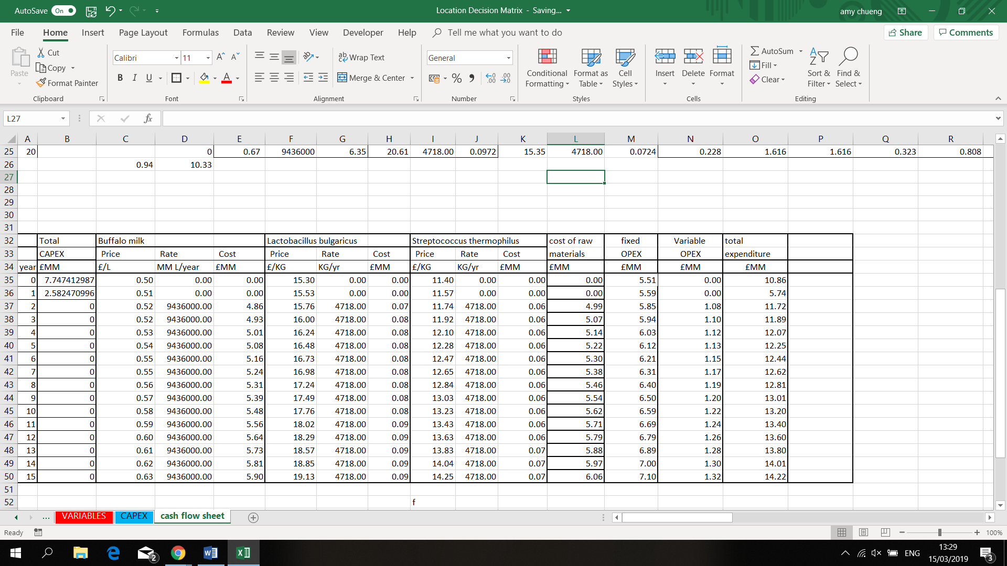

*Table 8: Cost of raw materials annually*

3333

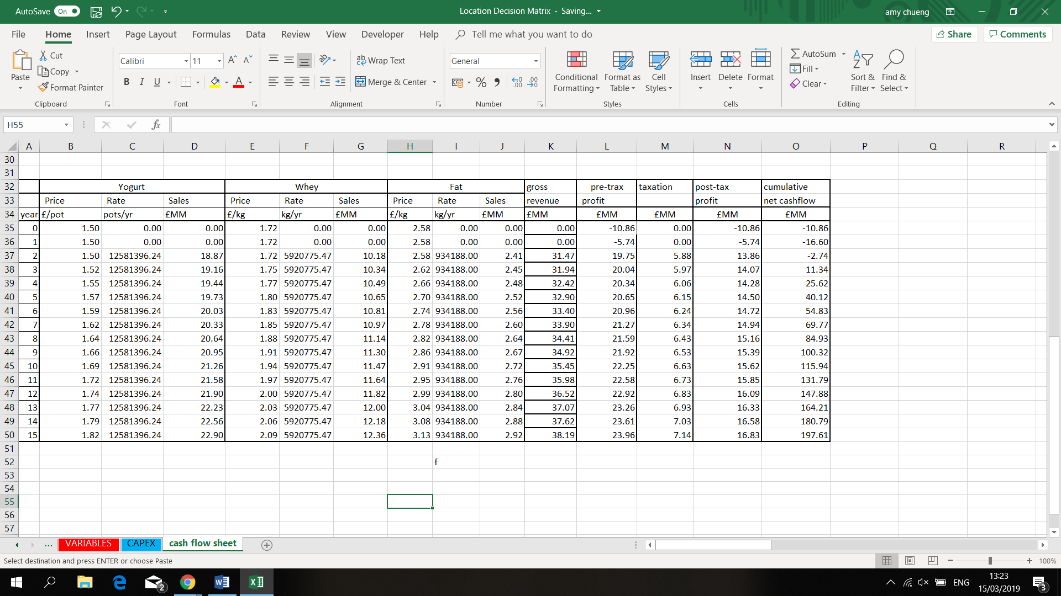

*Table 9: Determination of cumulative cash flow with all revenue*

34

**Net Present worth calculation**

Sample calculation of the NPW at the end of the company’s lifespan.

**Rate of returns and IRR**

ROR sample calculation:

|  |  |
| --- | --- |
| rate % | npw |
| 0 | £1,294.95 |
| 5 | £749.83 |
| 10 | £452.13 |
| 15 | £282.05 |
| 20 | £180.78 |
| 25 | £118.14 |
| 30 | £78.02 |
| 35 | £51.52 |
| 40 | £33.50 |
| 45 | £20.93 |
| 50 | £11.97 |
| 55 | £5.45 |
| 60 | £0.62 |
| 65 | -£3.01 |
| 70 | -£5.78 |
| 75 | -£7.91 |

*Table 10: Determination of IRR percentage*

35

**Profitability index**

36

#### Marketing appendices

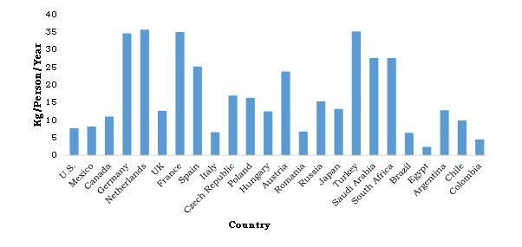

*Figure 14: Annual per capita yogurt consumption*

37

|  |  |
| --- | --- |
| Date | 22/01/2019 |
| Time | 11:15 AM |
| Location | Learning Commons, Heriot Watt University |
| Attendees | Murtaza Naqvi  Harry Nicholl  Amy Chung  Maria Caeli  Bethany Mulliner |
| Minutes By | Murtaza Naqvi |

# Meeting Minutes

|  |  |  |  |  |
| --- | --- | --- | --- | --- |
| Item | Action Taken | Action Needed | Status | Deadline |
| 1. Discussion of aim and initial plans | This was the first meeting and the initials plans of what products will chose;’;’and the process taken to | Each member to come up with a product yogurt and a method to proceed with | Open | Next meeting |
| 1. Allocation of roles | Members decided among themselves each individuals group roles | This will be finalised in the coming week, when better knowledge of each person’s strengths is known | Close | 15/11/18 |

38

|  |  |
| --- | --- |
| Date | 30/01/2019 – 31/01/2019 |
| Time | 11:15 AM |
| Location | JN building, Heriot Watt University |
| Attendees | Murtaza Naqvi  Harry Nicholl  Amy Chung  Maria Caeli  Bethany Mulliner |
| Minutes By | Murtaza Naqvi |

|  |  |  |  |  |
| --- | --- | --- | --- | --- |
| Item | Action Taken | Action Needed | Status | Deadline |
| 1. Discussion of aim and initial plans | The decision of making Greek style yogurt from buffalo milk was chosen and was discussed with supervisors | Each person to find out the most economical and efficient method of creating buffalo yogurt. | Open | Next meeting |
| 1. Allocation of roles | A clear structure of each individual’s role was created and allocated | None | Closed |  |
| 1. Market research and location of plant |  | The market analysis and the location of the plan was to be determined | Open | 2 Weeks |

39

|  |  |
| --- | --- |
| Date | 07/02/2019 |
| Time | 11:15 AM |
| Location | Learning Commons, Heriot Watt University |
| Attendees | Murtaza Naqvi  Harry Nicholl  Amy Chung  Maria Caeli  Bethany Mulliner |
| Minutes By | Murtaza Naqvi |

|  |  |  |  |  |
| --- | --- | --- | --- | --- |
| Item | Action Taken | Action Needed | Status | Deadline |
| 1. Continuation of research | Continuation of research into the buffalo yogurt the production and process | Induvial research into their own topics | Open | Next meeting |
| 1. Peer assessments due |  | Hand in peer assessments | Open | Friday 1st March 2019 |

40

|  |  |
| --- | --- |
| Date | 15/02/2019 |
| Time | 11:15 AM |
| Location | Learning Commons, Heriot Watt University |
| Attendees | Murtaza Naqvi  Harry Nicholl  Amy Chung  Maria Caeli  Bethany Mulliner |
| Minutes By | Murtaza Naqvi |

|  |  |  |  |  |
| --- | --- | --- | --- | --- |
| Item | Action Taken | Action Needed | Status | Deadline |
| 1. Continuation of research | Continuation of research into the buffalo yogurt the production and process | Induvial research and completion of their own topics | Open | Next meeting |
| 1. Journal review paper to be selected | N/A | Selects an appropriate journal paper | Open | Week 10 |
| 1. Week 8 Presentation | None | Prepare a PowerPoint to briefly explain each individual sections | Open | Week 8 |

41

|  |  |
| --- | --- |
| Date | 22/02/2019 |
| Time | No meeting held this week |
| Location | N/A |
| Attendees | Murtaza Naqvi  Harry Nicholl  Amy Chung  Maria Caeli  Bethany Mulliner |
| Minutes By | Murtaza Naqvi |

|  |  |  |  |  |
| --- | --- | --- | --- | --- |
| Item | Action Taken | Action Needed | Status | Deadline |
| 1. Continuation of research | Continuation of research into the buffalo yogurt the production and process | Induvial research into their own topics | Open | Next meeting |
| 1. Peer assessments due |  | Hand in peer assessments | Open |  |
| 1. Week 8 Presentation | None | Prepare a PowerPoint to briefly explain each individual sections | Open | Week 8 |
| 1. No meeting held this week as no new items were required |  |  |  |  |

42

|  |  |
| --- | --- |
| Date | 28/02/2019 |
| Time | 11:15 AM |
| Location | JN building, Heriot Watt University |
| Attendees | Murtaza Naqvi  Harry Nicholl  Amy Chung  Maria Caeli  Bethany Mulliner |
| Minutes By | Maria Caeli |

|  |  |  |  |  |
| --- | --- | --- | --- | --- |
| Item | Action Taken | Action Needed | Status | Deadline |
| 1. Finding more information to complete mass balance | Discussing on what information were missing | Aiming to complete the mass balance | Open | Next meeting |
| 1. Feedback during the presentation | Considering of adding on-site water treatment | Research about water treatment method | Open | Next meeting |
| 1. Draft report | Final check to ensure every section has been completed | Everyone completing their individual section | Open | By Thursday week 8 |

43

|  |  |
| --- | --- |
| Date | 12/03/2019 |
| Time | 10:00 AM |
| Location | Café in town |
| Attendees | Murtaza Naqvi  Harry Nicholl  Amy Chung  Maria Caeli  Bethany Mulliner |
| Minutes By | Maria Caeli |

|  |  |  |  |  |
| --- | --- | --- | --- | --- |
| Item | Action Taken | Action Needed | Status | Deadline |
| 1. Feedback on draft report | Everyone has read the feedback and discuss on what improvement can be made | Each individual continues to work on the report based on the feedback | Open | Next meeting |
| 1. Journal summary | Final check to ensure every section has been completed | Everyone completing their journal review | Open | By week 10 |
| 1. Presentation week 11 | Discuss all the key points needed for the presentation | Prepare a PowerPoint to briefly explain each individual sections | open | By the end of the week |

44

|  |  |
| --- | --- |
| Date | 20/03/2019 |
| Time | 9:00 AM |
| Location | JN crush area |
| Attendees | Murtaza Naqvi  Harry Nicholl  Amy Chung  Maria Caeli  Bethany Mulliner |
| Minutes By | Maria Caeli |

|  |  |  |  |  |
| --- | --- | --- | --- | --- |
| Item | Action Taken | Action Needed | Status | Deadline |
| 1. Final preparation before the presentation | Run through the final practice before the presentation | none | Open |  |

45

|  |  |
| --- | --- |
| Date | 25/03/2019 |
| Time | No physical meeting |
| Location | - |
| Attendees | Murtaza Naqvi  Harry Nicholl  Amy Chung  Maria Caeli  Bethany Mulliner |
| Minutes By | Maria Caeli |

|  |  |  |  |  |
| --- | --- | --- | --- | --- |
| Item | Action Taken | Action Needed | Status | Deadline |
| 1. Final report | Everyone go through their section and ensure that most of the section has been completed and revised based on the feedback | Completing individual section and formatting the final report | Open | Week 12 |

46

# References

## market analysis

Agr.gc.ca. (2018). *Sector Trend Analysis – Dairy trends in Western Europe - Agriculture and Agri-Food Canada (AAFC)*. [online] Available at: http://www.agr.gc.ca/eng/industry-markets-and-trade/international-agri-food-market-intelligence/reports/sector-trend-analysis-dairy-trends-in-western-europe/?id=1527090439391 [Accessed 17 Mar. 2019].

Allied Market Research. (2017). *Yogurt Market by Type (Set Yogurt, Greek Yogurt, Yogurt Drinks, and Frozen Yogurt) and Distribution Channel (Supermarkets/Hypermarkets, Independent Retailers, Specialist Retailers and Convenience Stores) - Global Opportunity Analysis and Industry Forecast, 2017-2023*. [online] Available at: https://www.alliedmarketresearch.com/yogurt-market [Accessed 1 Mar. 2019].

Bizjournals.com. (2017). [online] Available at: https://www.bizjournals.com/prnewswire/press_releases/2017/07/10/BR37578 [Accessed 2 Mar. 2019].

Dairy UK. (2018). *The UK Dairy industry | Dairy UK*. [online] Available at: https://www.dairyuk.org/the-uk-dairy-industry/ [Accessed 3 Mar. 2019].

En.wikipedia.org. (2019). *Düsseldorf*. [online] Available at: https://en.wikipedia.org/wiki/D%C3%BCsseldorf#Adjacent_cities_and_districts [Accessed 3 Mar. 2019].

Foodinsight.org. (2018). *2018 FOOD & HEALTH SURVEY*. [online] Available at: https://foodinsight.org/wp-content/uploads/2018/05/2018-FHS-Report-FINAL.pdf [Accessed 1 Mar. 2019].

Forbes.com. (2018). *Consumers Want Healthy Foods--And Will Pay More for Them*. [online] Available at: https://www.forbes.com/sites/nancygagliardi/2015/02/18/consumers-want-healthy-foods-and-will-pay-more-for-them/#5c39b9cf75c5 [Accessed 1 Mar. 2019].

Reference, G. (2019). *Lactose intolerance*. [online] Genetics Home Reference. Available at: https://ghr.nlm.nih.gov/condition/lactose-intolerance [Accessed 2 Mar. 2019].

Research, A. (2018). *Yogurt Market Expected to Reach $107,209 Million, Globally, by 2023*. [online] Prnewswire.com. Available at: https://www.prnewswire.com/news-releases/yogurt-market-expected-to-reach-107209-million-globally-by-2023-684284881.html [Accessed 2 Mar. 2019].

Worldpopulationreview.com. (2019). [online] Available at: http://worldpopulationreview.com/world-cities/dusseldorf-population/ [Accessed 3 Mar. 2019].

47

## Process description and flowsheeting

Reklaitis, G. and Schneider, D. (1983). *Introduction to material and energy balances*. New York: J. Wiley, p.Chapter 7.

Sinnott, R., Coulson, J. and Richardson, J. (2005). *Chemical engineering design*. Oxford: Elsevier Butterworth-Heinemann.

Canada, D. (2019). *The History of Yogurt - Yogurt | Dairy Goodness*. [online] Dairygoodness.ca. Available at: https://www.dairygoodness.ca/yogurt/the-history-of-yogurt [Accessed 28 Feb. 2019].

Donkor, O., Henriksson, A., Vasiljevic, T. and Shah, N. (2006). Effect of acidification on the activity of probiotics in yoghurt during cold storage. *International Dairy Journal*, 16(10), pp.1181-1189.

Yogurt, C. (2019). *Choosing Milk For Making Yogurt*. [online] Culturesforhealth.com. Available at: https://www.culturesforhealth.com/learn/yogurt/choosing-milk-for-making-yogurt/ [Accessed 1 Mar. 2019].

Sfakianakis, P. and Tzia, C. (2014). Conventional and Innovative Processing of Milk for Yogurt Manufacture; Development of Texture and Flavor: A Review. *Foods*, 3(1), pp.176-193.

Dairy Processing Handbook. (2019). *Dairy Processing Handbook*. [online] Available at: https://dairyprocessinghandbook.com/ [Accessed 1 Mar. 2019].

Ghafoor, A. and Munir, A. (2014). Thermo-economic Optimization of Solar Assisted Heating and Cooling (SAHC) System. *International Journal of Renewable Energy Development (IJRED)*, 3(3).

Karousou, N. and Stefanou, F. (n.d.). [online] Available at: https://ec.europa.eu/energy/intelligent/projects/sites/iee-projects/files/projects/documents/sahc_in_the_agrofood_sector.pdf?fbclid=IwAR01G9c5l5IY5ZfwqZLaMJrz3PuIjGHoQfOGFz7fPA0qxDFkphNDxGjJ1A4 [Accessed 21 Feb. 2019].

M. Abd Elhamid, A. and M. Elbayoumi, M. (2017). Effect of Heat Treatment and Fermentation on Bioactive Behavior in Yoghurt Made from Camel Milk. *American Journal of Food Science and Technology*, 5(3), pp.109-116.

Scharl, M., Geisel, S., Vavricka, S. and Rogler, G. (2010). Dying in Yoghurt: The Number of Living Bacteria in Probiotic Yoghurt Decreases under Exposure to Room Temperature. *Digestion*, 83(1-2), pp.13-17.

48

## SUSTAINABILITY

Erickson, B. E., 2017. Acid whey: Is the waste product an untapped goldmine?. *Chemical and Engineering News,* 95(6), pp. 26-30.

The European Parliament and the Council of the European Union, 2004. *REGULATION (EC) No 853/2004 OF THE EUROPEAN PARLIAMENT AND OF THE COUNCIL "laying down specific hygiene rules for on the hygiene of foodstuffs".* Brussels: Official Journal of the European Union.

Wibax, n.d. *Dust-binding.* [Online]   
Available at: https://wibax.com/en/produktgrupp/dust-binding  
[Accessed 26 February 2019].

## Health and safety

Alibaba, 2019. *Complete industrial yogurt making processing machine.* [Online]   
Available at: https://www.alibaba.com/product-detail/Complete-industrial-yogurt-processing-making-machine_1563717637.html?spm=a2700.7724857.normalList.59.6b8870813JULwZ  
[Accessed 15 march 2019].

Anon., n.d.

CFI Education, 2019. *Internal Rate of Return (IRR).* [Online]   
Available at: https://corporatefinanceinstitute.com/resources/knowledge/finance/internal-rate-return-irr/  
[Accessed 14 march 2019].

CFI Education, 2019. *Rate of Return.* [Online]   
Available at: https://corporatefinanceinstitute.com/resources/knowledge/finance/rate-of-return-guide/  
[Accessed 14 march 2019].

Chen, J., 2019. *Investipedia.* [Online]   
Available at: https://www.investopedia.com/terms/p/profitability.asp  
[Accessed 14 march 2019].

CLAL, 2019. *CLAL.it.* [Online]   
Available at: https://www.clal.it/en/?section=grafici_burro&fbclid=IwAR3MasrMI7A-jc5LVi3d5JldEmAwrt_0Ld29RXlKhAyKmfrs8nGs2cwcwjA  
[Accessed 14 march 2019].

Erickson, B. E., 2017. Acid whey: Is the waste product an untapped goldmine?. *Chemical and Engineering News,* 95(6), pp. 26-30.

Expatica, 2019. *Minimum wage and average salary in Germany.* [Online]   
Available at: https://www.expatica.com/de/employment/employment-law/minimum-wage-and-average-salary-in-germany-995112/  
[Accessed 13 March 2019].

Financing and Incentives Team: Friedrich Henle, M. S., 2018. *Incentives in Germany, Supporting Your Investment Project,* Berlin: Germany Trade and Invest.

Food Standards Agency Scotland (FSAS), 2006. *Milk Hygiene on the dairy farm,* s.l.: s.n.

Global property guide, 2019. *Square Metre Prices - Germany Compared to Europe.* [Online]   
Available at: https://www.globalpropertyguide.com/Europe/germany/square-meter-prices  
[Accessed 13 march 2019].

Hennig, P. D. F. H. (. a. D., 2019. *Investing in German Real Estate,* Berlin: PricewaterhouseCoopers GmbH Wirtschaftsprüfungsgesellschaft.

Kay Moller, S. N. P. W. A. S., 2012. *Benchmarking in the wastewater sector-taking stock,* Hamburg: s.n.

Kenton, W., 2019. *Investopedia.* [Online]   
Available at: https://www.investopedia.com/terms/n/npv.asp  
[Accessed 14 march 2019].

Maverick, J. B., 2019. *Limitations of Using a Payback Period for Analysis.* [Online]   
Available at: https://www.investopedia.com/ask/answers/062915/what-are-some-limitations-and-drawbacks-using-payback-period-analysis.asp

Peavler, R., 2019. *The Profitability Index.* [Online]   
Available at: https://www.thebalancesmb.com/the-profitability-index-392917  
[Accessed 14 march 2019].

Riggin, d. J., 2007. *The Importance of Calculating a Capital Charge for Insurable Risk Hedging Strategies.* [Online]   
Available at: https://www.irmi.com/articles/expert-commentary/the-importance-of-calculating-a-capital-charge-for-insurable-risk-hedging-strategies  
[Accessed 13 march 2019].

Sinnot, R. K., 2005. *Coulson & Richardson's Chemical Engineering Design.* Oxford OX28DP: s.n.

Sueli Cusato, A. H. G. C. H. C. A. S. S., 2013. *Food Safety Systems in a Small Dairy Factory,* Sa˜o Paulo, Brazil: s.n.

The European Parliament and the Council of the European Union, 2004. *REGULATION (EC) No 853/2004 OF THE EUROPEAN PARLIAMENT AND OF THE COUNCIL "laying down specific hygiene rules for on the hygiene of foodstuffs".* Brussels: Official Journal of the European Union.

Trading Economics, 2019. *Germany Corporate Tax Rate.* [Online]   
Available at: https://tradingeconomics.com/germany/corporate-tax-rate

Trading Economics, 2019. *Germany Inflation Rate.* [Online]   
Available at: https://tradingeconomics.com/germany/inflation-cpi  
[Accessed 13 march 2019].

Wibax, n.d. *Dust-binding.* [Online]   
Available at: https://wibax.com/en/produktgrupp/dust-binding  
[Accessed 26 February 2019].

50

## economics

Alibaba, 2019. *Complete industrial yogurt making processing machine.* [Online]   
Available at: https://www.alibaba.com/product-detail/Complete-industrial-yogurt-processing-making-machine_1563717637.html?spm=a2700.7724857.normalList.59.6b8870813JULwZ  
[Accessed 15 march 2019].

Anon., n.d.

CFI Education, 2019. *Internal Rate of Return (IRR).* [Online]   
Available at: https://corporatefinanceinstitute.com/resources/knowledge/finance/internal-rate-return-irr/  
[Accessed 14 march 2019].

CFI Education, 2019. *Rate of Return.* [Online]   
Available at: https://corporatefinanceinstitute.com/resources/knowledge/finance/rate-of-return-guide/  
[Accessed 14 march 2019].

Chen, J., 2019. *Investipedia.* [Online]   
Available at: https://www.investopedia.com/terms/p/profitability.asp  
[Accessed 14 march 2019].

CLAL, 2019. *CLAL.it.* [Online]   
Available at: https://www.clal.it/en/?section=grafici_burro&fbclid=IwAR3MasrMI7A-jc5LVi3d5JldEmAwrt_0Ld29RXlKhAyKmfrs8nGs2cwcwjA  
[Accessed 14 march 2019].

Erickson, B. E., 2017. Acid whey: Is the waste product an untapped goldmine?. *Chemical and Engineering News,* 95(6), pp. 26-30.

Expatica, 2019. *Minimum wage and average salary in Germany.* [Online]   
Available at: https://www.expatica.com/de/employment/employment-law/minimum-wage-and-average-salary-in-germany-995112/  
[Accessed 13 March 2019].

Financing and Incentives Team: Friedrich Henle, M. S., 2018. *Incentives in Germany, Supporting Your Investment Project,* Berlin: Germany Trade and Invest.

Food Standards Agency Scotland (FSAS), 2006. *Milk Hygiene on the dairy farm,* s.l.: s.n.

Global property guide, 2019. *Square Metre Prices - Germany Compared to Europe.* [Online]   
Available at: https://www.globalpropertyguide.com/Europe/germany/square-meter-prices  
[Accessed 13 march 2019].

Hennig, P. D. F. H. (. a. D., 2019. *Investing in German Real Estate,* Berlin: PricewaterhouseCoopers GmbH Wirtschaftsprüfungsgesellschaft.

Kay Moller, S. N. P. W. A. S., 2012. *Benchmarking in the wastewater sector-taking stock,* Hamburg: s.n.

Kenton, W., 2019. *Investopedia.* [Online]   
Available at: https://www.investopedia.com/terms/n/npv.asp  
[Accessed 14 march 2019].

Maverick, J. B., 2019. *Limitations of Using a Payback Period for Analysis.* [Online]   
Available at: https://www.investopedia.com/ask/answers/062915/what-are-some-limitations-and-drawbacks-using-payback-period-analysis.asp

Peavler, R., 2019. *The Profitability Index.* [Online]   
Available at: https://www.thebalancesmb.com/the-profitability-index-392917  
[Accessed 14 march 2019].

Riggin, d. J., 2007. *The Importance of Calculating a Capital Charge for Insurable Risk Hedging Strategies.* [Online]   
Available at: https://www.irmi.com/articles/expert-commentary/the-importance-of-calculating-a-capital-charge-for-insurable-risk-hedging-strategies  
[Accessed 13 march 2019].

Sinnot, R. K., 2005. *Coulson & Richardson's Chemical Engineering Design.* Oxford OX28DP: s.n.

Sueli Cusato, A. H. G. C. H. C. A. S. S., 2013. *Food Safety Systems in a Small Dairy Factory,* Sa˜o Paulo, Brazil: s.n.

The European Parliament and the Council of the European Union, 2004. *REGULATION (EC) No 853/2004 OF THE EUROPEAN PARLIAMENT AND OF THE COUNCIL "laying down specific hygiene rules for on the hygiene of foodstuffs".* Brussels: Official Journal of the European Union.

Trading Economics, 2019. *Germany Corporate Tax Rate.* [Online]   
Available at: https://tradingeconomics.com/germany/corporate-tax-rate

Trading Economics, 2019. *Germany Inflation Rate.* [Online]   
Available at: https://tradingeconomics.com/germany/inflation-cpi  
[Accessed 13 march 2019].

Wibax, n.d. *Dust-binding.* [Online]   
Available at: https://wibax.com/en/produktgrupp/dust-binding  
[Accessed 26 February 2019].

52